REGION – SOUTH ASIA

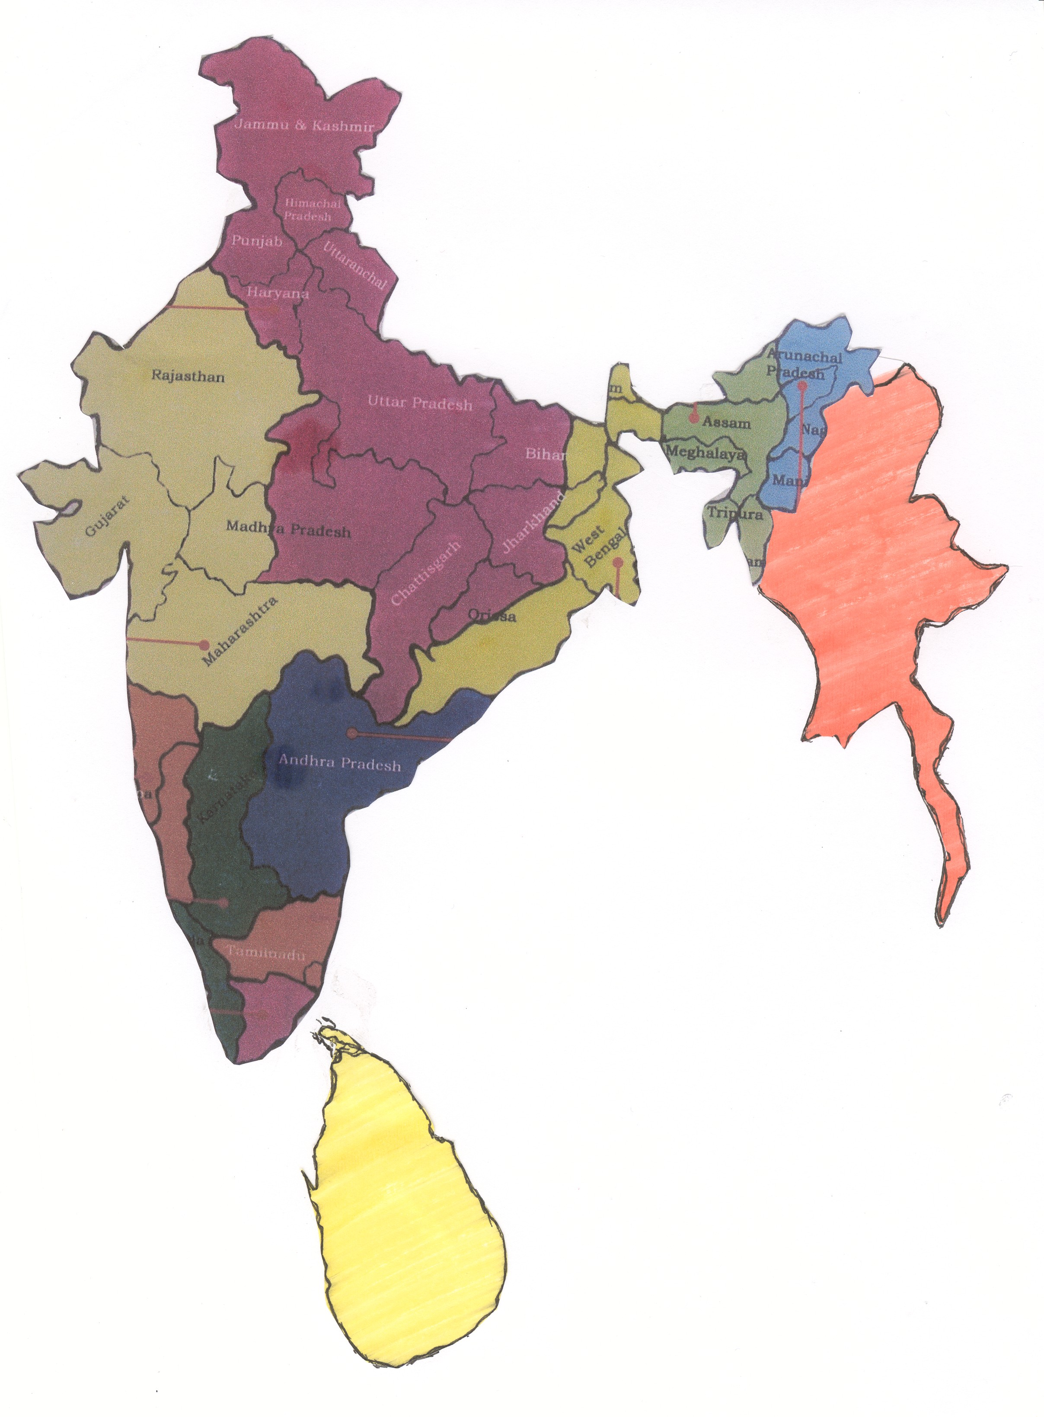

Vice Province

SRI LANKA

Vice Province

MYANMAR

Vice Province

KONKAN

Province

TIRUCHY

Province

BOMBAY

Province

BANGALORE

Province

MADRAS

Province

CALCUTTA

Province

NEW DELHI

Province

GUWAHATI

Province

DIMAPUR
PROVINCES VICE PROVINCE
(1) Calcutta 1926 (1) Konkan 2004
(2) Madras 1934 (2) Myanmar 2004
(3) Guwahati 1959 (3) Sri Lanka 2004
(4) Bombay 1972
(5) Bangalore 1979
(6) Dimapur 1981
(7) Hyderabad 1992
(8) New Delhi 1997
(9) Tiruchy 1999

